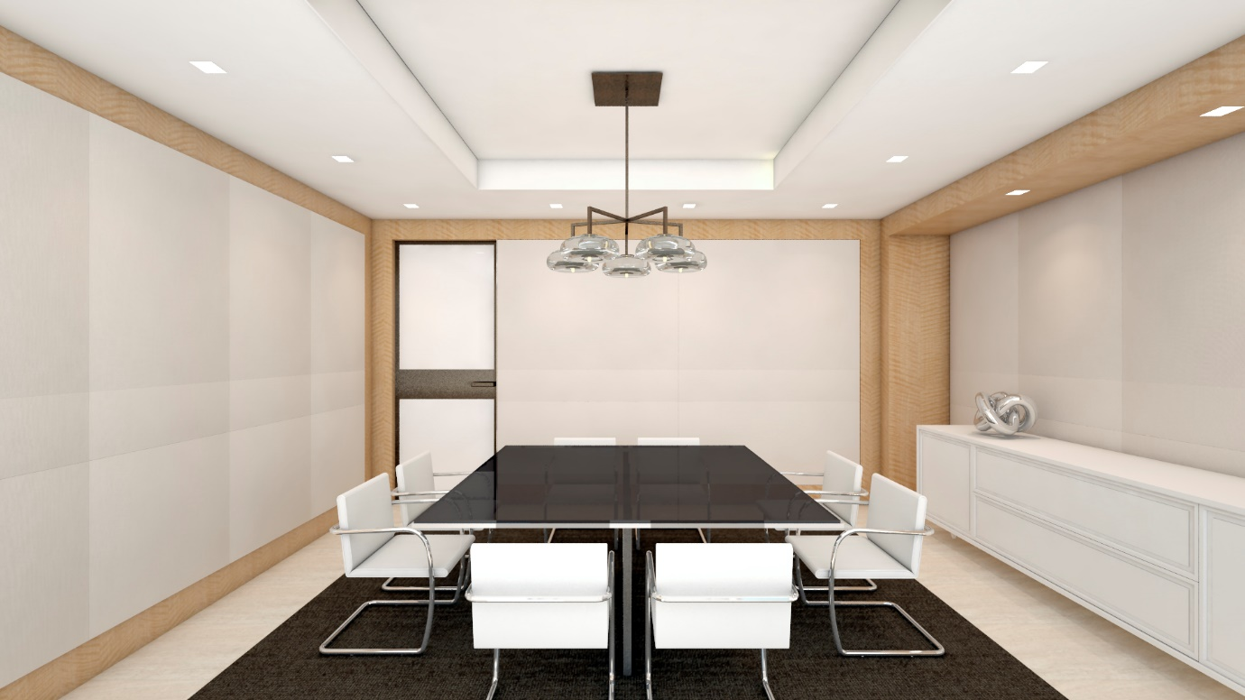

Picture 1

clean style; the walls around can be the transparent display.

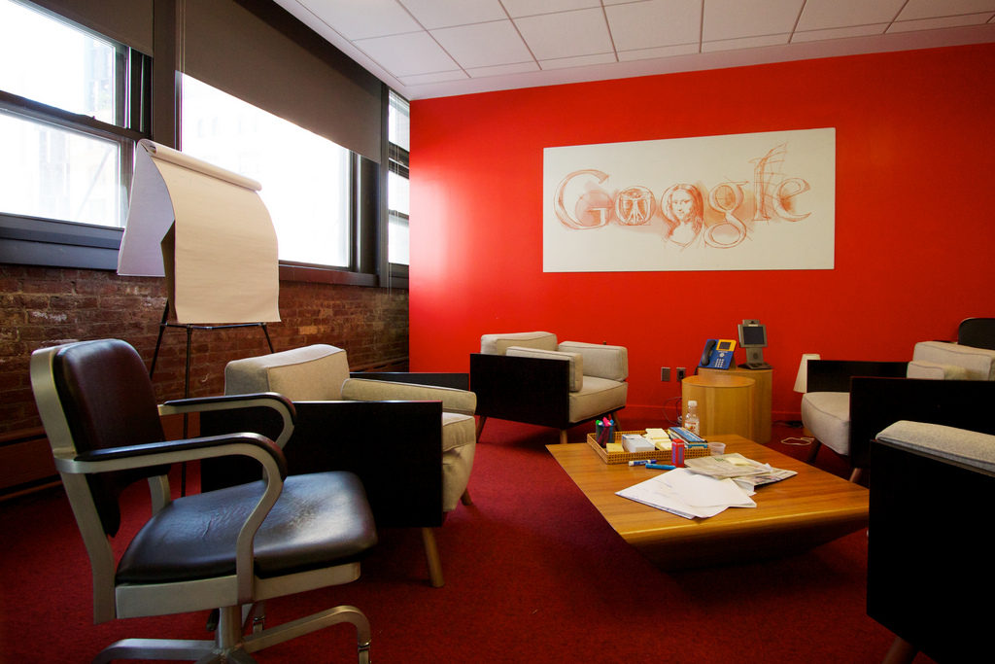

Picture 2

Leisure style, but only the red wall can be the transparent display.

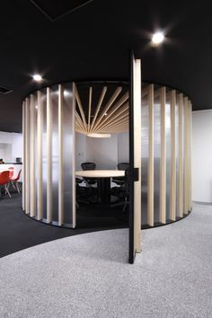

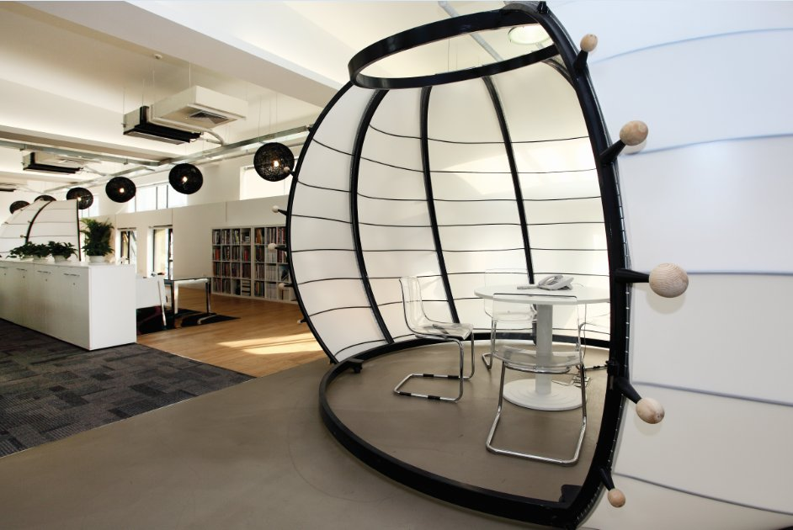

Picture 3 & 4

Around room, model style, but no place to put the display.

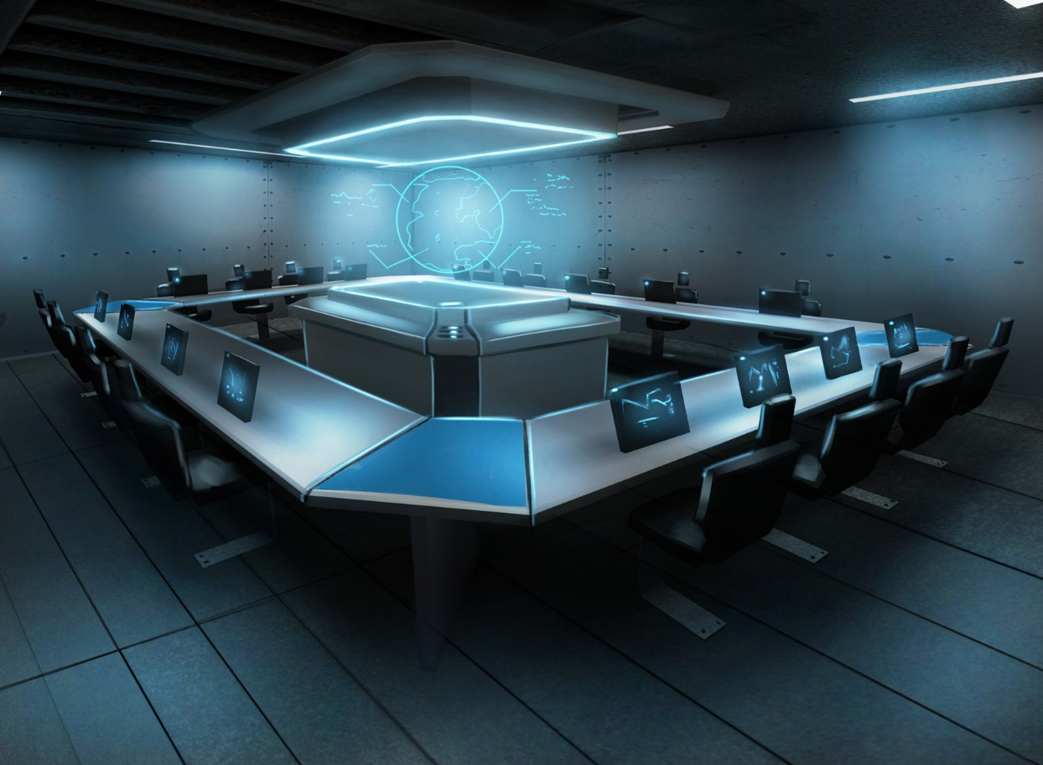

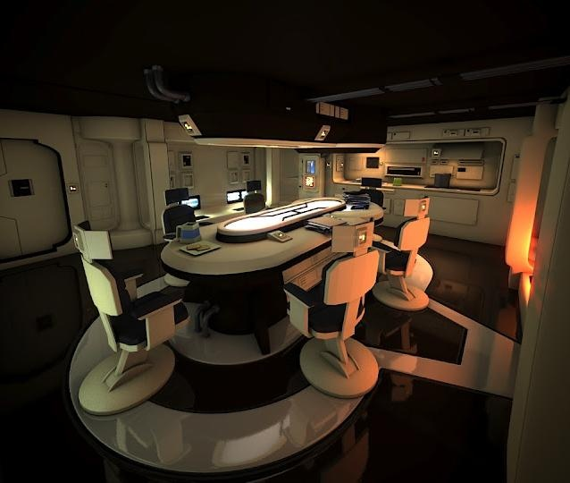

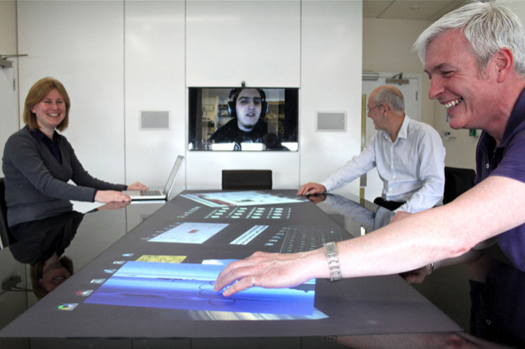

Picture 5 &6 &7

If the display change the place, from wall to the table, or just floating , the room style or size it will be alright.

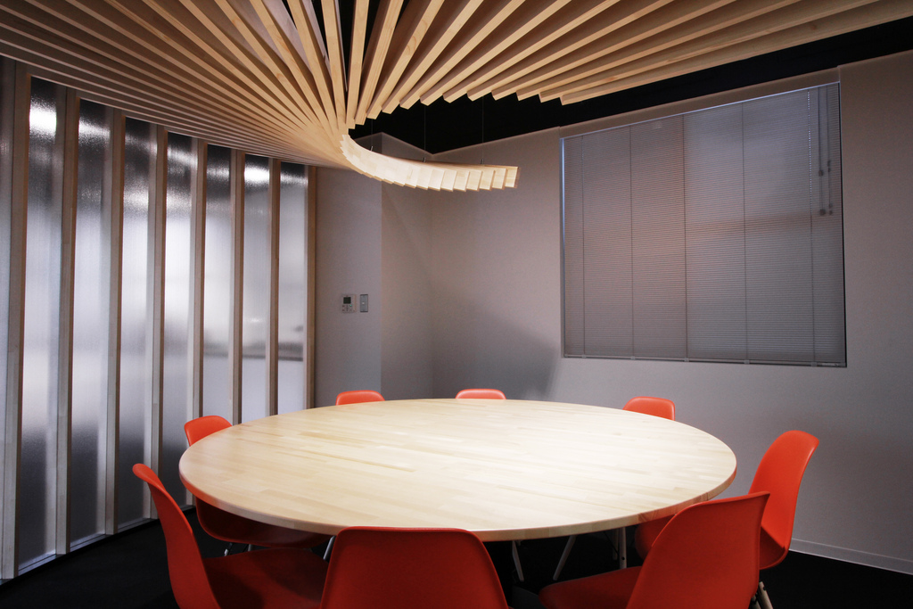

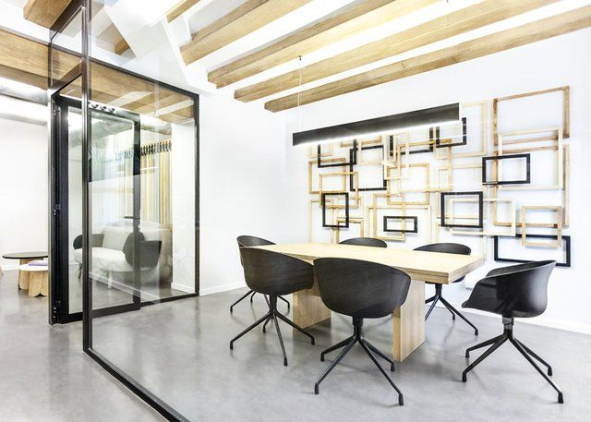

Picture8 & 9

Just give the other room style.